Becca Sowards
11/25/2017
FCDS 2640-1
Lesson Plan (3rd Grade)
Lesson Plan Title: We’re Not That Different After All: Human Development and Relationships
Core Standard/Objective:
Health Education Standard 3: The students will understand and respect self and others related to human development and relationships.
Health Education Objective 2: Model behaviors that foster healthy and diverse relationships.
Primary purpose of the lesson: Having positive, supporting, and respectful relationships can improve various aspects of life including; strengthening health, the mind, and relationships with others. As communities, schools, and homes become increasingly diverse, developing an early understanding of diversity is important for social and emotional development. As children learn about their various interpersonal relationships they will begin to understand how everyone is alike, but also different.
Essential Question(s):
- What are the benefits of healthy relationships among peers, family, and community members?
- How do different relationships change over time?
- How can I respect people who are different than me?
- How can I contribute to healthy relationships among peers? Family? Community members?
Content Objective: The students will explore what diversity means and what it looks like in the classroom and community. They will learn the value respect and how to implement it within various relationships.

Language Objective: Students will describe uses of respect in various settings orally and through the display of their writing and pictures. They will be able to demonstrate kindness through their use of language and actions.

Vocabulary: Diversity, “careless words”, “valuing differences”, being courteous, interpersonal relationships

Materials Needed:
- Hooway for Wodney Wat Author-Helen Lester, Illustrator-Lynn Munsinger
- Access to Internet with appropriate strength of speakers to play video, “For the Birds-Think before you act” A Pixar-Short Film (https://www.youtube.com/watch?v=LI92DLRdKYE)
- Large sheet of butcher paper labeled “Looks like vs Sounds like”
- Tape
- Art Paper and colored markers for each student
Pre-Assessment: Students will stand about a foot away from a line (marked with tape). They will respond to the following guiding questions after watching the video; if the answer is “yes” they will step forward to the line. If the answer is “no” they will stay where they are.
- Who knows what Diversity is?
- Who Knows what respect means?
- Who knows how to be respectful?
- Who knows what careless means?
- Who knows what an interpersonal relationship is?
After each question, the teacher will ask the children at the line for a definition or explanation. The word (respect, careless, interpersonal relations) with associated answer will be written on the board as a frame of reference for the class lesson.
Connect/engage:
- Watch the short-film, “For the Birds-Think Before You Act”. Discuss with the students why the small birds didn’t like the big bird. What were the small birds feeling? What did the big bird want? What was he feeling? Talk about how the outcome could have been better resolved. What could the small birds have done differently? What could the Big bird have done differently?
- “Read the book Howoay for Wodney Wat. Discuss why Wodney Wat was shy and bashful. How was Wodney Wat feeling at the beginning of the book? How was he different? How could the animals better have treated Wodney? How did Wodney feel at the end of the book? How can we make sure to include everyone in the class?
Step by Step Procedure:
- Start by creating a space in the front or center of the room and having the class sit on the floor in a group.
- Introduce the class to the lesson.
- Show the short-film, “For the Birds-Think Before You Act”. Explain to the students that they need to pay close attention because afterwards you will ask them follow-up questions. Following the film Reflect and relate by asking questions.
- Perform the pre-assessment game by first explaining the rules of the line and corresponding answers of “yes and no”. Second, ask the question and come up with classroom definitions to write on the board.
- Have the class sit down and explain that you’re going to read a book. Similar to the film, they need to pay attention so you can talk about it afterwards. Post book discuss the above questions as discussion topics. This time the situations becomes more closely linked to the classroom and classmates. Make sure to incorporate new vocabulary words on the board.
- The Class sits back in desks as the teacher hands out the “You vs. Me” Venn Diagram handout. Have each student complete the chart about themselves and a person of their choice (not family). Explain the instructions. The student’s unique qualities will go in the first circle, the unique qualities of the person being compared will go in to the second circle, and the qualities in common will go in the center where the circles overlap. Draw an example on the board. Walk around the room to provide assistance and answer questions.
- Each student will be asked to stand up and share one thing from each column in their diagram. After each student has shared, reinforce the idea of uniqueness and diversity in the classroom and outside the classroom. Briefly talk about how different skills are needed for different roles in life (example jobs) and how being different is important. Discuss how careless words can make others feel like their differences are bad and how it can hurt their feelings.
- Close the lesson.

Plan for independent work: In third grade children begin to think abstractly and make more rational judgments when processing their surroundings. This is a great lesson for the children to internalize the cause and effect their words and actions have on people. Allow the children to think as a team but also independently. During the You vs. Me diagram children can build a sense of ownership over their work. They are allowed to choose who they pick to compare themselves against. This activity is scaffold with concrete expectations and instructions. While they work, allow time to be responsive to those who need additional help or clarification. Provide an example if needed or requested. Push the child to using his/her own creativity as they explore all sorts of differences (besties just physical).
Closure: Wrap up the class by reemphasizing the importance of valuing differences. The closure should really solidify the feel of a classroom community. Assign the students homework. Ask each student to go home and ask a parent or sibling about one thing that is unique to their family, culture, or a custom. Have the child write it on the back of the Venn Diagram (prompted question) and bring it back to class the next day to discuss. Explain that this is a topic that they will continue to focus on and to be thinking about to better appreciate the Wodneys of the classroom.
Post assessment: Take one-minute at the end of class to have the children write one thing that they learned or thought was important in their classroom journal. Once dismissed read the journals to analyze the comprehension of each child. Note those who may not have totally grasp the concept yet so that you can provide further assistance. Note what information needs to repeated in future lessons.
Integrated Extensions/Links to subjects:
-Have children sort into groups based on various categories (similarities and differences)
-Read a different book, “The Way I Act”.
-Make an acronym project for the word “RESPECT”
-Visit a museum the demonstrates different cultures (social studies/history).

Adaptions:
- Try to allow the children to make as many choices on their own as possible. However, do not give a choice that is not an option.
- Accept alternative ways to communicate. Not all children are verbal, read mannerisms and non-verbal communications (gestures, noises, and facial expressions) as answers to questions.
- Switch up space by moving the children from a nosey group space to an individual desk space. These breaks can often allow a child to regroup if the stimulation of a group becomes too intense.
- REPEAT and PRACTICE. It’s the best way for the children to understand the lesson. While individuals work is progressing walk around the room to formatively evaluate if anyone needs individualized help.
- Make sure there are clear paths between each activity for children that have difficulty moving from one spot to the next.
- Allow children who move slowly the opportunity to go to an area first and leave first in order to minimize collisions.
- Tape Ven Diagram paper to table if more stability is needed.

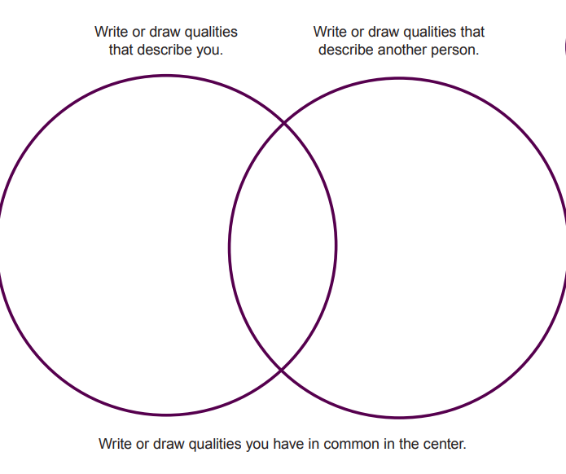
Differences Vs. Similarities

Homework
Name: ___________
Due: _____________
Today we talked about how each person in Mrs. Sowards class is different but that each person is important in making up our classroom. What is one thing that is unique and special to your family? Maybe you have a unique tradition or custom? What makes your family different?

