Multi-Sensory Interventions for Children and Adolescents with Autism Spectrum Disorders:
Translating Research into Recreational Therapy Practice

Erika Hummel, Rhonda Nelson, Portia Millet, Jenni Perkins and Rebecca Sowards
University of Utah Department of Occupational and Recreational Therapies

Search Terms: adolescents, autism, autism spectrum disorder, children, developmental disability, intellectual disability, multi-sensory, multi-sensory intervention, multi-sensory environment, multi-sensory room, and Snoezelen
Years: 2004 - 2017
Databases: Academic Search Premier, CINAHL, Education Full Text, ERIC, Google Scholar, MEDLINE, PsycARTICLES, PsychINFO, SPORTDiscus

Research Summary
Autism Spectrum Disorder (ASD) is a neurodevelopmental disorder characterized by deficits in social communication, nonverbal communicative behaviors, and restricted repetitive patterns of behavior, interest, or activities (American Psychiatric Association, 2013). With estimates of 1 in 68 children/adolescents currently diagnosed, ASD is a prevalent health issue (Centers for Disease Control and Prevention, 2017), and innovative treatments are needed.
Multi- sensory interventions hold potential to address a number of health issues common to individuals with ASD. While multi-sensory environments have been used to provide multi-sensory interventions for individuals with a variety of disabilities since the late 1970’s (Fowler, 2008), limited research currently exists related to their effectiveness. Utilizing equipment that engages the senses, these environments aim to either stimulate or relax the participant in a variety of therapeutic activities (Snoezelen, 2017).
To understand how multi-sensory interventions might be utilized to benefit children and adolescents with ASD, this literature review included eight research-based sources (seven journal articles and one dissertation) with relevance to this population. Given the limited research available exclusive to the target population, studies were included that involved participants with similar conditions. Subjects included children and adults with diagnoses of Autism Spectrum Disorder (Brandenburg, 2012; Fava & Strauss, 2010; Kaplan, Clopton, Kaplan, Messbauer, & McPherson, 2006), developmental disabilities (Shapiro, Sgan-Cohen, Parush, & Melmed, 2009; Singh et al., 2004), intellectual disabilities (Kaplan et al, 2006; Van der Putten, Vlaskamp, & Schuivens, 2011), and traumatic brain injury (Hotz et al., 2006). Other subjects were described by researchers as participants with severe challenging behaviors (Kaplan et al., 2006), profound mental retardation (Fava & Strauss, 2010), and as patients of a general psychiatric hospital who exhibited high levels of aggression and destructive behavior (McKee, Harris, Rice, & Silk, 2007).
Interventions varied, but were all presented as individual rather than group treatment sessions. Most sessions were conducted in Snoezelen rooms (Fava & Strauss, 2010; Hotz et al., 2006; Kaplan et al., 2006; McKee et al., 2007; Singh et al., 2004), or multi-sensory environments (Brandenburg, 2012; Van der Puten et al., 2011). However, one study adapted an environment designated for other purposes by using mobile multi-sensory equipment (Shapiro et al., 2009). The studies that yielded the most significant results utilized sessions that lasted 15-30 minutes at least 2-3 times per week, over 4-10 weeks (Brandenburg, 2012; Fava & Strauss, 2010; Hotz et al., 2006; Kaplan et al., 2006). The study that offered longer sessions lasting up to 90 minutes (McKee et al., 2007) did not produce significant outcomes.
Unfortunately, the majority of the studies lacked both descriptions of specific equipment used and activities that occurred with participants in the MSE, making intervention replication difficult. Only one study (Brandenburg, 2012) specified that participants were given a choice of two items with which to engage depending on their assessed sensory needs. However, participants were not directed through specific activities. Still, the author attributed positive outcomes to the use of individualized treatment plans for each participant (Brandenburg, 2012).
Results documented decreases in anxious and agitated behaviors (Hotz et al., 2006; Shapiro et al., 2009); aggressive acts such as kicking, punching, hitting, slapping (Singh et al., 2004); self-injurious behaviors such as biting, slapping, and head banging (Singh et al., 2004); stereotypic behaviors such as rocking, snapping, and flapping (Brandeburg, 2012); and challenging and disruptive behaviors (Fava & Strauss, 2010; Kaplan et al., 2006, McKee et al., 2007) following multisensory interventions. Positive behaviors were also recorded, with participants exhibiting increased task engagement (Kaplan et al., 2006); and increased prosocial behaviors (Fava & Strauss, 2010; McKee et al., 2007).

Knowledge Translation for Recreational Therapy Practice
Based on the evidence presented above, Recreational Therapists can consider using multisensory interventions to target and decrease anxiety (Hotz et al., 2006), aggression, self-injurious behavior (Fava & Strauss, 2010; Kaplan et al., 2006), and stereotypic behaviors (Brandenburg, 2012) in children and adolescents with ASD. Positive behaviors such as task engagement (Kaplan et al., 2006), and pro-social behaviors (Fava & Strauss, 2010; McKee et al., 2007) can also be maximized through MSI.
For greatest benefits, it is recommended that the MSI is structured based on an individualized treatment plan, and offered as individual rather than group treatment. Current literature supports 20 - 30 minute sessions, offered 2-3 times per week over 4-10 weeks in order to yield positive outcomes in the areas noted above. It is not recommended that sessions exceed 30 minutes, as longer sessions have not produced significant results (McKee et al, 2007) potentially due to boredom or over-stimulation.
Given the lack of detail currently available regarding specific therapeutic interventions and approaches, therapists are encouraged to develop and document structured MSI activity protocols targeting outcomes in the areas noted above. It is also recommended that information be compiled on specific multisensory equipment and environments (e.g. multisensory room vs. portable equipment) that lead to positive outcomes in individuals with ASD. This will assist in advancing therapeutic treatment and evidence-based practices in this area.
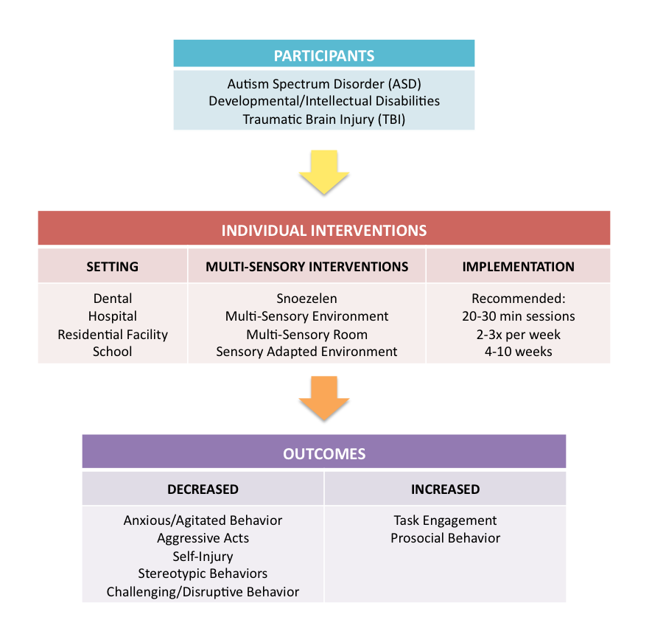

References
American Psychiatric Association. (2013). Diagnostic and Statistical manual of mental disorders (5th ed.). Washington, DC: Author.
Brandenburg, L. A. (2012), The effects of multi-sensory environments on the stereotypic behaviors of children with autism (Doctoral dissertation). Retrieved from ProQuest LLC (Accession #ED556802).
Centers for Disease Control and Prevention (2017). Autism spectrum disorder. Retrieved March 10, 2017, from https://www.cdc.gov/ncbddd/autism/data.html
Fava, L., & Strauss, K. (2010). Multi-sensory rooms: Comparing effects of the Snoezelen and the stimulus preference environment on the behavior of adults with profound mental retardation. Research in Developmental Disabilities, 31(1), 160-171.
Fowler, Susan. (2008). Multisensory rooms and environments: Controlled sensory experiences for people with profound and multiple disabilities. London: Jessica Kingsley Publishers
Hotz, G. A., Castelblanco, A., Lara, I. M., Weiss, A. D., Duncan, R., & Kuluz, J. W. (2006). Snoezelen: A controlled multi-sensory stimulation therapy for children recovering from severe brain injury. Brain Injury, 20(8), 879-888. doi:10.1080/02699050600832635
Kaplan, H., Clopton, M., Kaplan, M., Messbauer, L., & McPherson, K. (2006). Snoezelen multi-sensory environments: Task engagement and generalization. Research in Developmental Disabilities, 27(4), 443-455.
McKee, S. A., Harris, G. T., Rice, M. E., & Silk, L. (2007). Effects of a Snoezelen room on the behavior of three autistic clients. Research in Developmental Disabilities, 28(3), 304-316.
Shapiro, M., Sgan-Cohen, H. D., Parush, S., & Melmed, R. N. (2009). Influence of adapted environment on the anxiety of medically treated children with developmental disability. The Journal of Pediatrics, 154(4), 546-550.
Singh, N. N., Lancioni, G. E., Winton, A. S., Molina, E. J., Sage, M., Brown, S., & Groeneweg, J. (2004). Effects of Snoezelen room, activities of daily living skills training, and vocational skills training on aggression and self-injury by adults with mental retardation and mental illness. Research in Developmental Disabilities, 25(3), 285-293.
Snoezelen. (2017). Snoezelen multi-sensory environments, sensory room and therapy explained. Retrieved March 3, 2017, from http://www.snoezelen.info/history/
Van der Putten, A., Vlaskamp, C. and Schuivens, E. (2011), The use of a multisensory environment for assessment of sensory abilities and preferences in children with profound intellectual and multiple disabilities: A pilot study. Journal of Applied Research in Intellectual Disabilities, 24, 280–284. doi:10.1111/j.1468-3148.2010.00601.x

