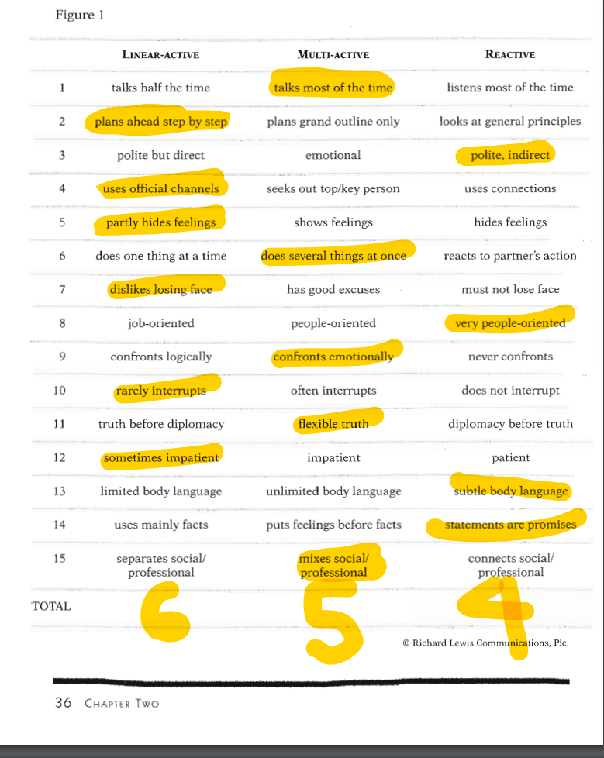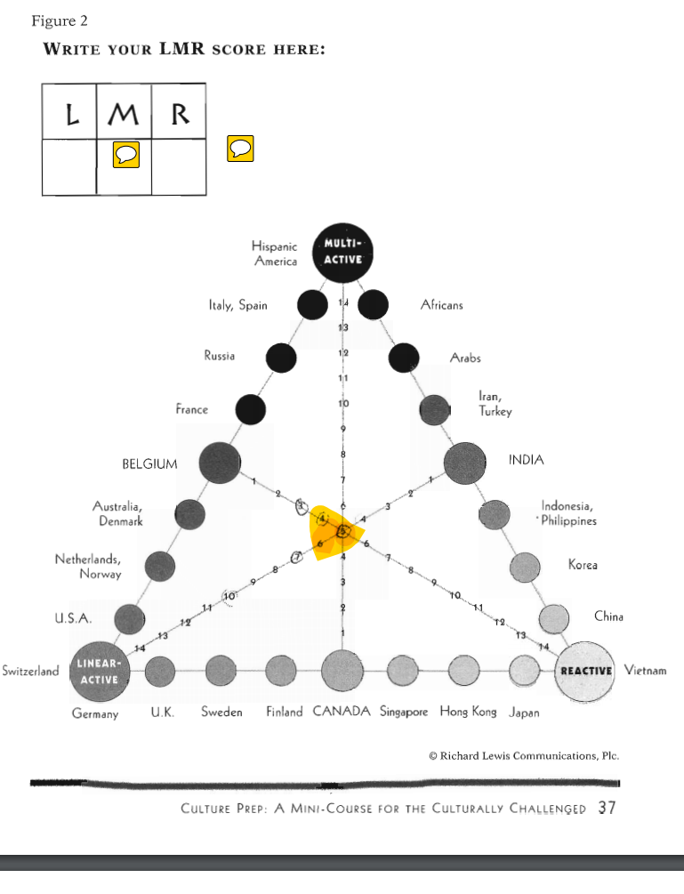

Who Am I? Reflection
After reading and completing the Lewis Model of Cultural Classification I scored 6 on the Linear-active, 5 on the multi-active, and 4 on the reactive scale. The results I received caught me by surprise due to the closeness of each category. While I was reading the chapter I classified myself in the multi-active Culture, however, these results suggest otherwise. When I placed my scores on the pyramid I had to double check my work to make sure that the image I saw was correct. It’s interesting to me to visually see how close I am to the center of all three types, with a slight lean to the left side of the scale. After studying my results I’ve concluded that maybe I’m not entirely honest with the way I view myself or the world around me. Experimenting with this model was a way in which I could identify that profile. The more I look at my results and read the given descriptions the more I believe it to be spot on.
According to the literature the United States of America falls under the Linear-Active Culture. Due to my score being the highest in this category I believe I am congruent with my surroundings and the values associated with my culture but only to the degree of belonging not entirely agreeing. I have such an influence from the other two views that I integrate them in a way that I don’t entirely fit in with my the classification of my Country. In fact, I’d say I’m falling further away from belonging to the U.S. culture as I get older and opinions surrounding me become more liberal. I would not, and neither would this model, classify myself as a true blooded Linear-active personality. It is interesting in understanding my interests in travel, live and work. I have a desire to travel foreign, it doesn’t matter where but someplace unique and different. I’m interested in all different types of languages, customs, and walks of life. I want to branch out from the United States. When it comes to calling a place my home, there isn’t a place I’d choose besides the United States of America. I’m proud of the Nation’s history and it’s constitutional rights even if I’m not proud of it’s current standings and movements. Above all else, my family is located here and for that reason, America is where I’ll always stay.
Characteristics I think fit me like a glove under the Linear-Active model include; sticking to planned agendas, gaining status through achievement, and working fixed hours. It’s interesting to think that the majority of my ancestry also falls under the same category as Linear-Active (Swiss, Norway, and Sweden). Characteristics I think i’m polar opposite of within the Active-Linear model include; fact oriented and speech as a main way to exchange information or communicate. I’m a very emotional driven person, and I think that is what makes me less congregant within my own classification category. My husband is 100% linear-active.
When it comes to communicating with the the other two culture types I don’t frequently run into problems. Multi-Active is probably the most common way I Communicate, I generally use animation and talk quickly to those around me. I like to make new friends and strengthen the ones that already exist. I would say the biggest set back I run into with multi-active cultures is either too much competition of popularity or even over the top buble personalities, both annoy me. When it comes to Reactive I would say I struggle with listening and patience. The individuals who are too methodical don’t last long in my conversations. I run into debating a lot with people who won’t stick up for their beliefs and Reactive tend to compromise for harmony. I struggle when others are too passive. I think I best communicate with these cultures over time. My relationships with them don’t come as easy as the others, they take personal effort. I struggle to maintain these types of relationships due to the fact I lose face often. To me it makes a person real when they express their emotion; in contrast this culture respects themselves and others significantly even to the point of blending their feelings, words, and actions into one.
I really enjoyed exploring this model and each aspect of my person “cultural classification”. It created patterns I wasn’t aware existed and forced me to look at myself at all most a third-person perspective. I gained a lot of insight about ways to better communicate within my own culture as well as others.

