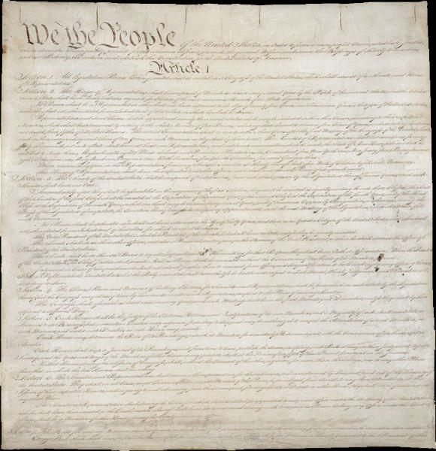

The United States Constitution
Becca Alley
History Section 001

"We the People of the United States, in Order to form a more perfect Union, establish Justice, ensure domestic Tranquility, provide for the common defense, promote the general Welfare, and secure the Blessings of Liberty to ourselves and our Posterity, do ordain and establish this Constitution for the United States of America."
— Preamble to the Constitution

This year marked one of the most monumental days in our Nation’s history, the 225th anniversary of the United States Constitution. Looking back from where we have come from, the countless changes in our government along with the numerous amendments to the document, America today still stands for freedom as it did when signed. It may catch you off guard, but our Nation has essentially had two constitutions. The very first being the Articles of Confederation, which created a weak federal system, and essential failed by giving the states too much power. After struggling to accomplish a proper functional government that the people hoped for, the founding fathers decided to essential start from scratch. What they came up with would change the course of the present and future. To sit down and read through the American history surrounding the one small but packed full of ideas document makes it unique in its own sense. But actually to look at the structure and what has developed and governed the way our society functions is what truly makes the Constitution of United States unique.
Our Founding Fathers studied the history of governments, taking bits and pieces from model countries and compiling them together to form what we have today known as a Republican form of government. This idea is unique because the power of government is held by the people. The people give power to leaders by election and they represent and serve their interests. The representatives are in return not only responsible for helping their personal political party but the, individual states, and the people of the country as a whole. A republican government ruled by the laws outlined in the Constitution recognizes the inalienable rights of individuals. To ensure no person or group would gain too much power the founders established a government in which the powers to create, implement, and enforce laws were separated. The government is therefore split up into three different branches; The Executive, Legislative, and Judicial Branch.
The power of the Executive Branch is vested in the President, who also acts as commander-in-chief. The president implements and enforces laws written by congress. The Legislature; established in Article I of the Constitution consists of the House of Represents and the Senate, which together form the Congress. Lastly is the judicial branch, which leaves congress to determine the shape and structure of the federal judiciary. In creating this balance of power, the framers of the constitution hoped to form what they referred to as “a more perfect union” A government that would not only serve the people but would also be a long lived exemplar to other nations around the world, an idea truly unique.
Some Citizens believe that the constitution should be looked at as black and white, something that should not be interpreted or altered in any way. However when forming the government the founding fathers realized they needed to allow flexibly. Hoping and striving for a document that would continually stand as the frame for a government even after generations passed they needed to incorporate important features. First most the Elastic clause, Congress shall make all laws necessary and proper, allowing for some room for expansion and interpretation of the constitution. Major examples would be the creation of a national bank, the purchase of the Louisiana territory, and hitting closer to home, Social security and Medicare. All of which aren’t defined powers in by the president or congress but were seemed “necessary and proper” at the time.
The second implemented the amendment process, which can be made in several ways. The first, the proposal process, is where two-thirds of the House or Representatives and the senate or two-thirds of states at a national Constitution Convention must pass the bill that causes for amendment. The second way is through Ratification where three-fourths of the state legislatures must vote yes to change, or three-fourths of state held conventions.
Third, Judicial Review which is a court’s authority to examine an act and to invalidate it if it is deemed contrary to constitutional principles. The constitution serves as a guideline but with the world ever changing and our nation ever expanding it will only last if the constitution changes with it. However, making it such a difficult and tedious process insures that most of the population must agree so as to not have a change that will self-destruct itself. The Constitution as a “living document” allows change, adaption and magnification in a unique way that it can change to fit its surroundings and suit them.
To set these things in stone the well-structured phrases were put into permanent ink and written upon paper making our constitution a Written Constitution opposed to our former rule, Great Britain who’s is unwritten. Their Constitution has evolved over many centuries, and unlike ours has not been assembled at any time into a single, consolidated document. Instead it is made up of common law and convention, along with various different written documents such as the Magna Carta, Bill of rights, and parliament acts. While there are advantages to an unwritten constitution, the disadvantages include no limitations on the legislative body, and an unclear devious of the powers of government. Without our written document we would not have the source of reference and ensures a underline order in our country. It allows the insurance of basic human rights, guaranteeing that government operates by its established rules and fundamental laws. It is used in court cases and makes up what we call our country.
Our nation founded on the rights of freedom of expression, religion, that all men are created equally and the right for “life, liberty and the pursuit of happiness.” Adopted the Constitution included only a few specific guaranteed rights. The writers drafting the constitution first vetoed the idea of a Bill of Rights, Thomas Jefferson in response said “A Bill of Rights is what the people are entitled to against every government on earth”, it is a corner stone for a greater sense of unity with personal identities and liberties. The document serves as a significant role in the changing society of other races and gender. This advancement to the Constitution outlines inalienable rights and the rights the government cannot infringe upon. One major Right outlined, not specified by other nations is religious views.
The Right to freedom of religion is very center to the American dream. In the First amendment it even states “congress shall make no law respecting an establishment of religion, or prohibiting the free exercise thereof…” Immigrants traveled in a pursuit of religious freedom to America, and it would almost be hypocritical to reverse that freedom now. It was made up of people wanting the “God given” freedoms taken away by other countries, and becomes important for government to continually honor it. References to God do exist all around us today some examples include; the national anthem The Star Spangle Banner and “In God we trust” written on our currency. Many people have questioned the legality of these mottos saying they violate the laws. However despite the founding fathers being religious and relying on guidance, these circumstances do not establish a religion but uses them in a patriot and ceremonial sense.
When you compare the United States government to other nations you can tell there is a difference. Our nation stands out and affects many others. The fact that it was constructed over two centuries ago brings up the ongoing argument over if the document is relevant in today’s world. However many fail to neglect the most unique aspect of why it has survived this long. The men writing did not right it to survive the advancements in society or technology however they focused on things that wouldn’t change with time, human nature. It still stands for the same cultural values, ethics, and virtues today as it did back in the 1780s. The constitution guarantees citizens the right to equal opportunities and to pursue to establish a better lifestyle, the American dream. The meanings in the words written on the constitution are ideas people don’t freely give up; people die for them every day. That is why the United States Constitution is extremely important and unique in the way something has never been written like it before.

Citation Page
- Dorf, Michael C. “THE CONSTITUTION CHANGING HISTORY”. Constitutional exam 28, no. 3 (Winter 2011)
- John, Roland. "Summary of Constitution rights, Powers and Duties." The Constitution. http://constitution.org/powright.htm. 2000. (Accessed November 23, 2012).
- Martinez, Jenny S. “International Courts and the U.S. Constitution: the History.” University of Pennsylvania Law Review 159, no. 4 (March 2011): 1069-1140, Academic Search Premier, EBSCOhost (accessed November 23rd)
- Paulsen, Michael Stokes. “Our Perfect Constitution.” Constructional Commentary 27, no. 3 (Winter 2011): 531-540. Academic Search Premier, EBSOhost
- Splain, Cheryl S. "The Constitution still being relevant today." Mount Vernon News . http://www.mountvernonnews.com/local/09/03/11/constitution-still-relevant-today. March 11, 2009 (accessed November 24, 2012).
- Stern, Alan. "The Living Constitution." Education Foundation. http://library.thinkquest.org/11572/constitution/important/living.html (accessed November 22, 2012).
- "The First Constitution-The Articles of Confederation." The Charters of Freedom. http://www.archives.gov/exhibits/charters/charters_of_freedom_4.html (accessed November 23, 2012).
- "Thomas Jefferson." The White House Presidents.” http://www.whitehouse.gov/about/presidents/thomasjefferson (accessed November 27, 2012).

"The First Constitution-The Articles of Confederation." The Charters of Freedom. http://www.archives.gov/exhibits/charters/charters_of_freedom_4.html (accessed November 23, 2012).
Martinez, Jenny S. “International Courts and the U.S. Constitution: the History.” University of Pennsylvania Law Review 159, no. 4 (March 2011): 1069-1140, Academic Search Premier, EBSCOhost (accessed November 23rd)
Edwin, Meese III. “The Meanign of the Constitution.” The Heritage Foundation. http://www.heritage.org/research/reports/2009/09/the-meaning-of-the-constitution (accessed November 25th, 2012)
Paulsen, Michael Stokes. “Our Perfect Constitution.” Constructional Commentary 27, no. 3 (Winter 2011): 531-540. Academic Search Premier, EBSOhost
Stern , Alan . "The Living Constitution." Education Foundation. http://library.thinkquest.org/11572/constitution/important/living.html (accessed November 22, 2012).
Dorf, Michael C. “THE CONSTITUTION CHANGING HISTORY”. Constitutional exam 28, no. 3 (Winter 2011)
"Thomas Jefferson." The White House Presidents . http://www.whitehouse.gov/about/presidents/thomasjefferson (accessed November 27, 2012).
John, Roland. "Summary of Constitution rights, Powers and Duties." The Constitution. http://constitution.org/powright.htm. 2000. (Accessed November 23, 2012).
Splain, Cheryl S . "The Constitution still being relevant today." Mount Vernon News . http://www.mountvernonnews.com/local/09/03/11/constitution-still-relevant-today. March 11, 2009 (accessed November 24, 2012).

